t

**Name: Taha hassan**

**Intern ID:TN/IN01/PY/017**

**Email ID : htaha6434@gmail.com**

**Internship Domain : python**

**Task Week : 2**

**Instructor Name :**

**Task 1 :**Create a mini profile for a fictional user using variables. Store the following information:

Full name , Age , Current year, Country, Hobby, Expected graduation year (calculate it from current year + 4)

Print all details in a proper sentence format.

Also print how many years are left till graduation.

**Solution :**

**CODE:**

# User information

full_name = "Taha Hassan"

age = 20

current_year = 2025

country = "pakistan"

hobby = "photography"

graduation_year = current_year + 4  # Calculated graduation year

# Print profile

print(f"Mini Profile:\n"

      f"Full Name: {full_name}\n"

      f"Age: {age}\n"

      f"Current Year: {current_year}\n"

      f"Country: {country}\n"

      f"Hobby: {hobby}\n"

      f"Expected Graduation Year: {graduation_year}")

# Calculate and print years left

years_left = graduation_year - current_year

print(f"\n{full_name} has {years_left} years left until graduation.")

**OUTPUT:**

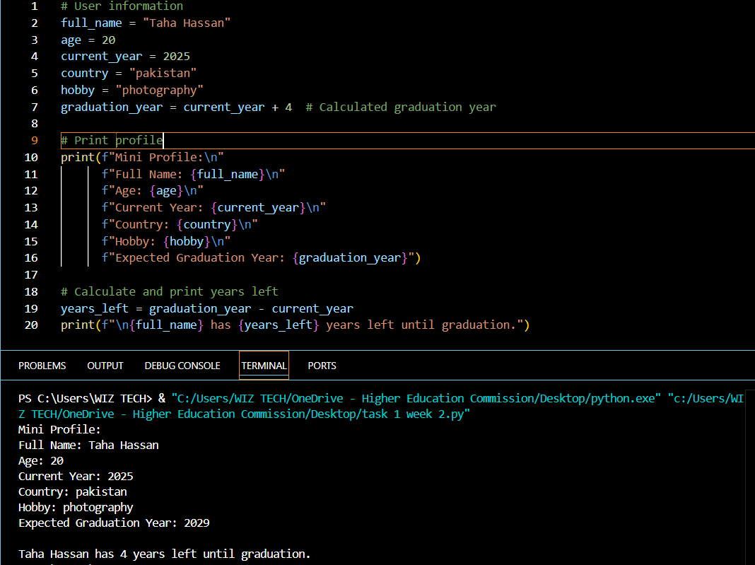

**TASK:2**

Create 3 different user profiles (using variables). For each profile, include: Name, profession, country, is_employed (Boolean) Print their data in a tabular format using print() (not with external libraries).

**CODE:**

name1 = "Taha Hassan"

profession1 = "editor"

country1 = "pakistan"

is_employed1 = True

# User Profile 2

name2 = "hammad"

profession2 = "Graphic Designer"

country2 = "Spain"

is_employed2 = False

# User Profile 3

name3 = "ali"

profession3 = "Data Scientist"

country3 = "China"

is_employed3 = True

# Convert employment status to readable strings

employed1 = "Employed" if is_employed1 else "Unemployed"

employed2 = "Unemployed" if not is_employed2 else "Employed"

employed3 = "Employed" if is_employed3 else "Unemployed"

# Print table header

print("\nUser Profiles:")

print(f"{'Name':<15} {'Profession':<20} {'Country':<10} {'Employment Status'}")

print("-" * 55)

# Print each user's data in table format

print(f"{name1:<15} {profession1:<20} {country1:<10} {employed1}")

print(f"{name2:<15} {profession2:<20} {country2:<10} {employed2}")

print(f"{name3:<15} {profession3:<20} {country3:<10} {employed3}")

**OUTPUT:**

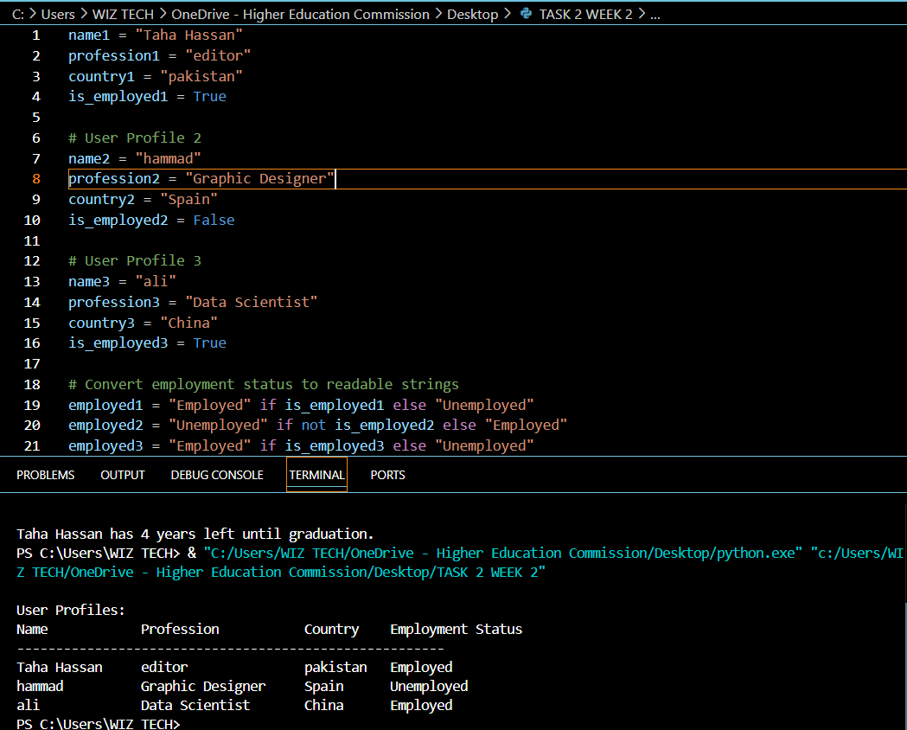

**TASK:3**

Write a program that:

Declares five different variables , Stores a different data type in each (e.g., string, integer, float, boolean, complex)

Prints their values and data types

Then, converts each variable to a different type (where possible) and prints the new types

Note: You may not be able to convert all types — handle errors or comment why.

**SOLUTION:**

# Original variables with different data types

text = "Hello" # String

number = 42 # Integer

decimal = 3.14 # Float

flag = True # Boolean

complex_num = 2+3j # Complex number

# Print original values and types

print("Original values:")

print(f"text: {text} ({type(text)})")

print(f"number: {number} ({type(number)})")

print(f"decimal: {decimal} ({type(decimal)})")

print(f"flag: {flag} ({type(flag)})")

print(f"complex_num: {complex_num} ({type(complex_num)})\n")

# Convert to different types

print("Converted values:")

# String -> Integer (only works for number strings)

converted_int = int("123") # Using different value for valid conversion

print(f"'123' converted to integer: {converted_int} ({type(converted_int)})")

# Integer -> String

converted_str = str(number)

print(f"{number} converted to string: '{converted_str}' ({type(converted_str)})")

# Float -> Integer (removes decimal part)

converted_float_to_int = int(decimal)

print(f"{decimal} converted to integer: {converted_float_to_int} ({type(converted_float_to_int)})")

# Boolean -> Integer (True=1, False=0)

converted_bool_to_int = int(flag)

print(f"{flag} converted to integer: {converted_bool_to_int} ({type(converted_bool_to_int)})")

# Complex -> String

converted_complex_to_str = str(complex_num)

print(f"{complex_num} converted to string: '{converted_complex_to_str}' ({type(converted_complex_to_str)})")

**TASK :4**

Create a data type tester:

Ask the user to input any value. , Detect and print what Python guesses its type as (use type()).

Add conditions to identify if it's likely an integer, float, or string, and print a message like:

"You entered a float!"

**SOLUTION:**

# Get user input

user_input = input("Enter any value: ")

# Try to detect data type

try:

    # Try converting to integer

    value = int(user_input)

    print(f"You entered an integer: {value}")

except ValueError:

    try:

        # Try converting to float

        value = float(user_input)

        print(f"You entered a float: {value}")

    except ValueError:

        # If both conversions fail, it's a string

        print(f"You entered a string: '{user_input}'")

# Show Python's actual type detection

print(f"Python detected type: {type(value).__name__}")

**OUTPUT:**

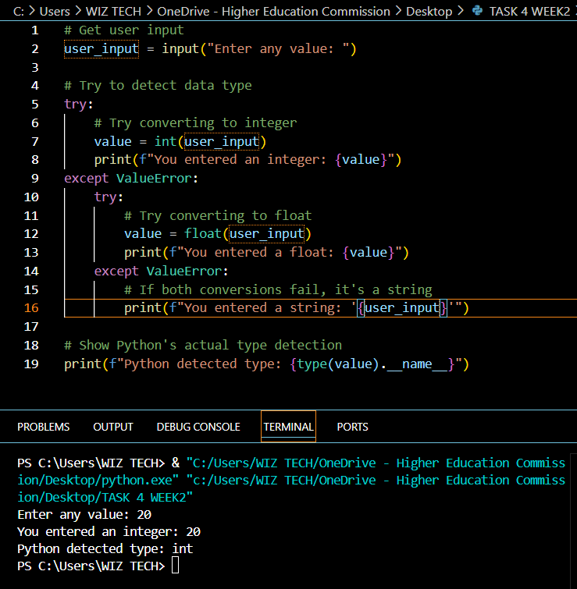

**TASK:5**

Design a command-line survey that:

Asks the user 5 different questions (e.g., name, favorite food, birth year, favorite number, favorite language)

Then prints a summary of all responses in sentence format.

Use formatting to make the output look professional (e.g., f-strings).

**SOLUTION:**

print("=== Welcome to the User Preferences Survey ===")

print("Please answer the following 5 questions:\n")

# Collect user responses

name = input("1. What is your full name? ")

fav_food = input("2. What's your favorite food? ")

birth_year = input("3. What year were you born? ")

fav_number = input("4. What's your favorite number? ")

fav_language = input("5. What's your favorite programming language? ")

# Calculate age (assuming current year is 2025)

current_year = 2025

age = current_year - int(birth_year) if birth_year.isdigit() else "N/A"

# Print professional summary

print("\n" + "="*50)

print("SURVEY SUMMARY".center(50))

print("="*50)

print(f" Name: {name.title()}")

print(f" Favorite Food: {fav_food.capitalize()}")

print(f" Birth Year: {birth_year} (Age: {age})")

print(f" Favorite Number: {fav_number}")

print(f" Favorite Programming Language: {fav_language.upper()}")

print("="*50)

print("Thank you for completing our survey!".center(50))

**OUTPUT:**

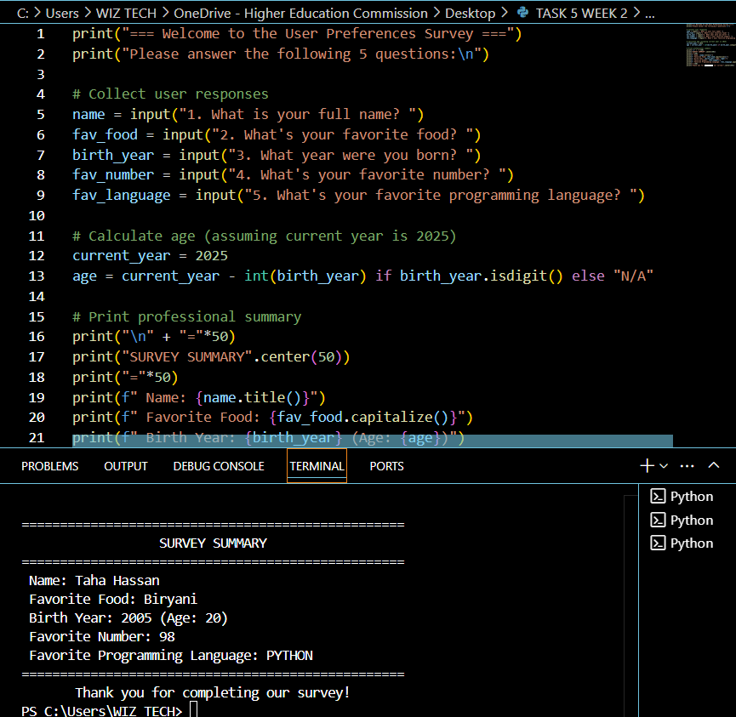

**TASK:6**

Ask the user to:

Enter their year of birth , Calculate their age (based on current year) ,Check if the user is eligible to vote (18+ years)

Display a message:

"You are eligible to vote." or "You are not eligible to vote yet."

**SOLUTION:**

current_year = 2025

# Get user input

birth_year = int(input("Please enter your year of birth: "))

# Calculate age

age = current_year - birth_year

# Check eligibility and display result

print(f"\nYou are currently {age} years old.")

if age >= 18:

    print(" You are eligible to vote!")

else:

    years_needed = 18 - age

    print(f" You are not eligible to vote yet.")

    print(f" You'll be eligible in {years_needed} year{'s' if years_needed > 1 else ''}.")

**OUTPUT:**

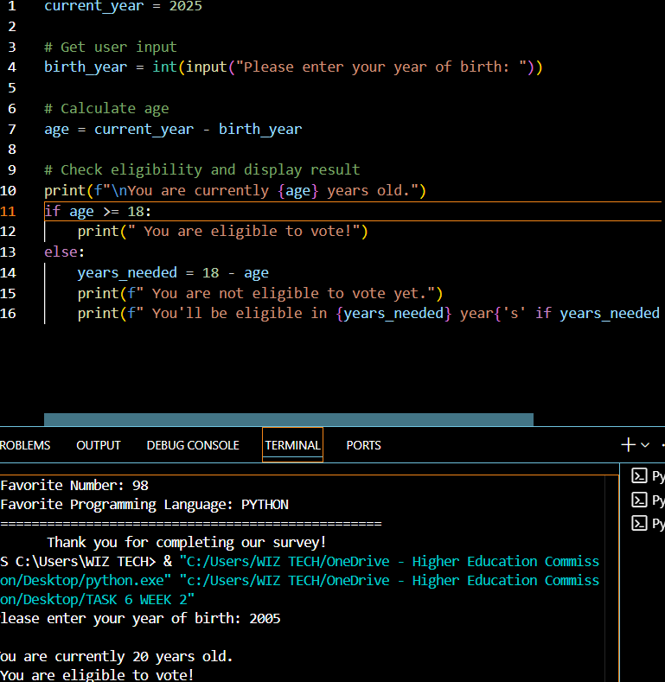

**TASK: 7**

Create a marks percentage calculator:

Ask user to input marks for 5 subjects (input as strings) , Convert them to integers

Calculate the total and percentage

Print percentage along with a grade: A (90+), B (80-89), C (70-79), Fail (<70)

**SOLUTION:**

print("=== Marks Percentage Calculator ===")

# Get marks for 5 subjects

subjects = ["Math", "Science", "English", "Physics", "Art"]

marks = []

for subject in subjects:

    while True:

        mark_str = input(f"Enter marks for {subject}: ")

        if mark_str.isdigit():

            mark = int(mark_str)

            if 0 <= mark <= 100:

                marks.append(mark)

                break

            else:

                print("Marks must be between 0-100. Try again.")

        else:

            print("Please enter a number. Try again.")

# Calculate total and percentage

total = sum(marks)

percentage = total / len(subjects)

# Determine grade

if percentage >= 90:

    grade = "A"

elif percentage >= 80:

    grade = "B"

elif percentage >= 70:

    grade = "C"

else:

    grade = "Fail"

# Print results

print("\n=== Results ===")

print(f"Total Marks: {total}/500")

print(f"Percentage: {percentage:.1f}%")

print(f"Grade: {grade}")

# Print grade message

if grade == "Fail":

    print("\n You need to improve your performance.")

else:

    print(f"\n Congratulations! You scored grade {grade}.")

**OUTPUT:**

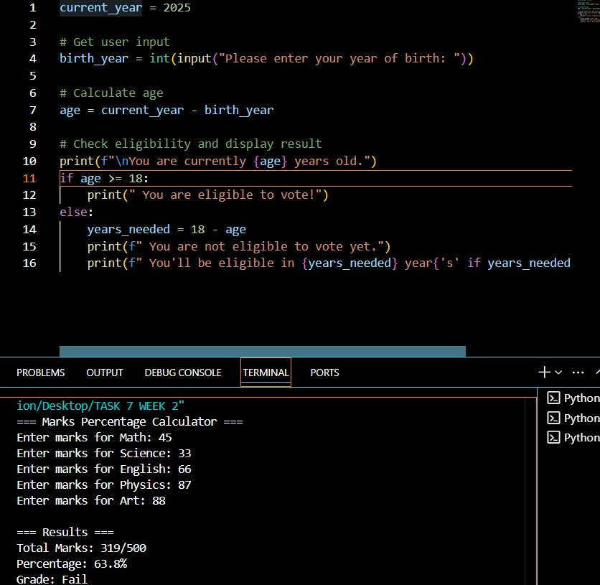

**TASK:8**

Create a temperature converter:

Ask the user to input temperature in Celsius.

Convert it to Fahrenheit using: F = (C * 9/5) + 32 , Then reverse: Ask for Fahrenheit, convert it to Celsius.

Handle wrong input types using try-except.

**SOLUTION:**

print(" Temperature Converter ")

# Celsius to Fahrenheit conversion

while True:

    try:

        celsius = float(input("\nEnter temperature in Celsius: "))

        fahrenheit = (celsius * 9/5) + 32

        print(f" {celsius}°C = {fahrenheit:.1f}°F")

        break

    except ValueError:

        print(" Please enter a valid number (e.g., 25 or 37.5)")

# Fahrenheit to Celsius conversion

while True:

    try:

        fahrenheit = float(input("\nEnter temperature in Fahrenheit: "))

        celsius = (fahrenheit - 32) * 5/9

        print(f" {fahrenheit}°F = {celsius:.1f}°C")

        break

    except ValueError:

        print(" Please enter a valid number (e.g., 77 or 98.6)")

**OUTPUT:**













